**Task 2**

Name: Abdul Azeez Mohamed Ismath

Student Id: 102434407

Git link: <https://github.com/leoazeez/COS30002-102434407>

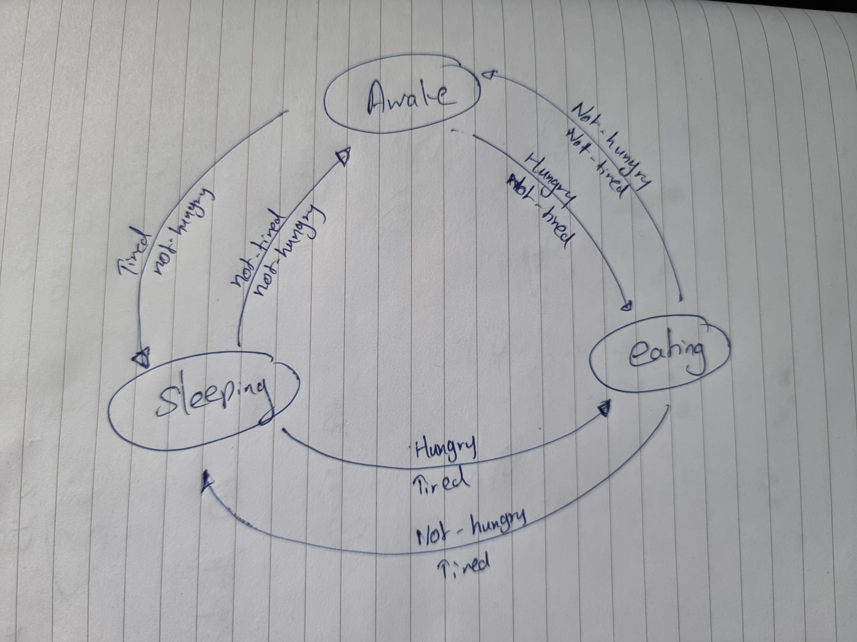

I have 2 variables and 3 states as stated above.

The diagram shows how as the variables change the state of the character changes aswell.

* If the character is hungry and tired he will be in eating state.
* If the character is hungry and not tired he will be in eating state.
* If the character is not hungry and not tired he will be in awake state.
* If the character is tired and not hungry he will be in sleeping state.

As you can see the eating stage is given more importance because if hunger goes above 20 the character will die.

Code:

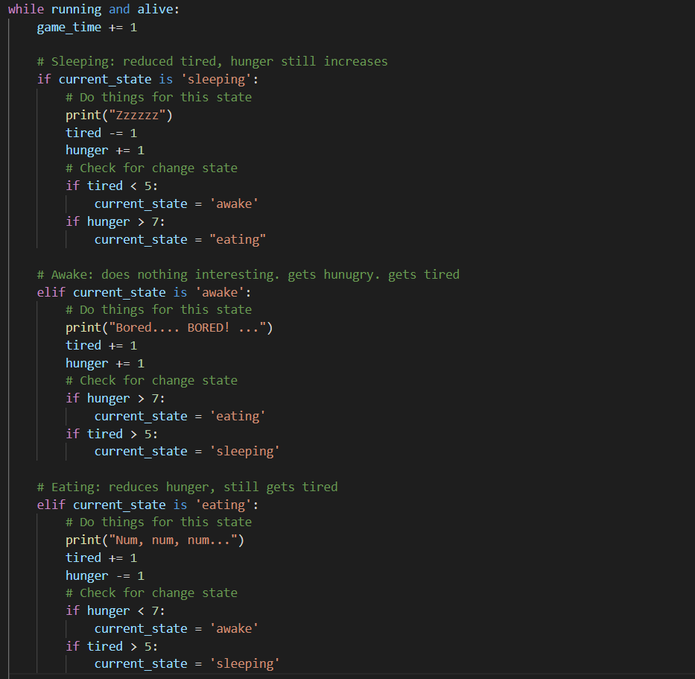

Output:

